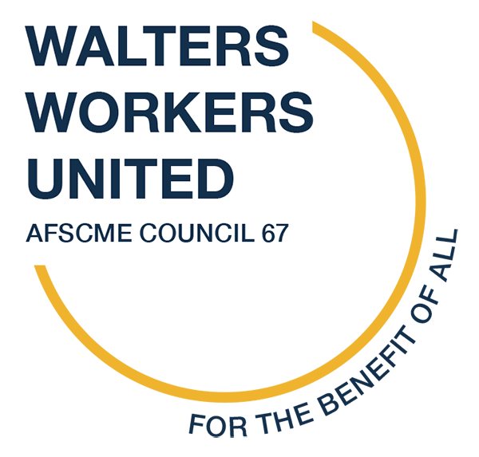
Contact: Kat Cancio FOR IMMEDIATE RELEASE: 1/17/23
(845) 271-9651
kcancio@afscme.org

Judge Nugent Decides in Favor of Walters Workers United in Maryland Public Information Act Lawsuit

BALTIMORE- On January 11, Judge John Nugent of the Baltimore City Circuit Court issued a ruling finding the Walters Art Museum an instrumentality of the government for the purposes of the Maryland Public Information Act. Walters Workers United (WWU), organizing with AFSCME, sought the ruling after museum leadership rejected a Maryland Public Information Act (MPIA) request for documents. The museum contended that it is not a public entity. It is. The Walters now has 30 days to respond to WWU’s records request.

On this ruling, AFSCME’s attorney David Maher states, “Judge Nugent’s ruling confirms WWU and AFSCME’s position that the Walters is a public entity, and that its employees are public sector employees. As the Walters has represented to the federal government, in tax filings, and in fundraising, the Walters is a public employer. It is subject to Maryland law regarding public sector entities. It houses public art, owned by the citizens of Baltimore City.”

Walters management has a track record of affirming their status as a government entity to claim its benefits - like special tax exemptions and access to federal government programs. But when it comes to governmental transparency and public employee rights to unionize, they conveniently try to identify otherwise. This ruling reminds management that they cannot reap public benefits without also meeting public responsibilities. WWU remains committed to the mission of the Walters to provide cultural enrichment to our communities and we will continue to hold them accountable to the citizens of Baltimore.

“Financial transparency from a public institution should be a given, and we owe the people of Baltimore City that much - the ability to see where their tax dollars are being spent, and how their art is managed. This ruling is a huge step forward towards accountability at the Walters,” Lex Reehill, Monitor Room Officer and an Organizing Committee member of Walters Workers United.
Maryland law allows the General Assembly to act and enable collective bargaining rights for employees of public employers and of any state created entities. This decision affirms that the Walters’ position, and its refusal to recognize its employees desire to be represented by a union which represents all of their colleagues, is incorrect and untenable. Delegate Robbyn Lewis (District 46) and Senator Jill Carter are sponsoring legislation with the Maryland General Assembly that would grant Walters employees collective bargaining rights and allow them to move forward with the recognition of their union. House Bill 116 is necessary to give Walters employees their fundamental right to freely choose whether to be represented by a union.

“I am proud to work for a free, public institution dedicated to the benefit of all. This ruling helps to ensure that our institution is accessible and accountable to those whom we serve and upon whose support we rely: citizens of Baltimore and the state of Maryland,” said Gregory Bailey, a Senior Objects Conservator at the Walters Art Museum and an Organizing Committee member of Walters Workers United.

# # #

